**PROJET REPORT TEMPLATE**

**1.INTRODUCTION**

At TechProSolution, we are dedicated to shaping the future of technology and providing cutting-edge IT solutions for businesses and individuals alike. As a leading IT company, we pride ourselves on our unwavering commitment to delivering top-tier services and products that empower our clients to thrive in the digital age.

Our journey began with a vision to bridge the gap between technology and your unique needs. With a team of talented professionals and a passion for innovation, we have established ourselves as a trusted partner for all your IT requirements. Our extensive range of services includes software development, IT consulting, cloud solutions, cyber security, and more. We cater to a diverse clientele, ensuring that each solution is tailor-made to enhance your efficiency, security, and competitiveness in a rapidly evolving tech landscape.

Our success is built on a foundation of expertise, a customer-centric approach, and a relentless pursuit of excellence. We understand that technology is the driving force behind progress and success in the modern world. That's why we are committed to staying at the forefront of industry trends and advancements, providing you with the most up-to-date and innovative solutions.

TechProSolution is more than just a company; we're your partner in the journey towards technological transformation and success. Join us in exploring the limitless possibilities of IT, and together, we'll unlock the future. Your success is our mission, and we look forward to embarking on this exciting technological journey with you. Welcome to TechProSolution - where your vision meets our expertise.

* 1. **OVERVIEW**

We utilize the latest technology to provide sophisticated and secure IT solutions using an effective delivery model to ensure flexibility and agility. Our specialty of operations includes Application Lifecycle Management, Infrastructure Lifecycle Management and Product Lifecycle Management. Our “High performance business” strategy builds on our expertise in consulting, technology and outsourcing to help clients perform at the highest levels so that they can create sustainable value for their customers and shareholders. Using our industry knowledge, service-offering expertise and technological capabilities, we identify new business and technology trends and develop solutions to help clients across the globe. For our clients, we offer a flexible and supportive work environment that focuses on the needs and career development goals of its people; while always focusing on delivering the highest quality.

### Our Vision

We strive to be a trusted partner as an IT Solution provider. We are committed to achieve Customer’s Business Objectives by Delivering Professional Services & adopting Innovative Technologies.

### Our Mission

To channelize the Knowledge, Expertise and Experience that has gained over the years from recommending IT products and Effective solutions for our Customers. Deep industry knowledge and exceptional technical expertise combined with best business ethics makes TechPro the global leader in IT Services and Management Consulting.

Services provided by the Techprosolution there are:

# ****IT Consulting****: They provide expert advice and guidance to businesses on how to use technology to achieve their goals and solve specific problems. This may include technology strategy, system audits, and recommendations.

# ****Software Development****: IT companies design, develop, and maintain custom software applications for businesses, which can range from web and mobile apps to enterprise-level software solutions.

# ****Website Development and Design****: Web development and design services encompass creating and maintaining websites, e-commerce platforms, and web applications.

# ****Cloud Services****: IT companies offer cloud computing services, such as Infrastructure as a Service (IaaS), Platform as a Service (PaaS), and Software as a Service (SaaS) solutions. This can include cloud migration, management, and optimization.

# ****Cybersecurity****: Protecting digital assets is crucial, and IT companies offer services like security audits, threat assessments, firewall setup, and ongoing monitoring to safeguard against cyber threats.

* 1. **PURPOSE**

Our have typically several common purposes, including:

1. **Providing Technology Solutions**: IT companies exist to offer a range of technology-related services and solutions to their clients. This could include software development, network administration, cybersecurity, cloud computing, and more.
2. **Enabling Digital Transformation**: Many IT companies help businesses and organizations embrace digital transformation. They assist in adopting new technologies to streamline operations, improve efficiency, and stay competitive in the digital age.
3. **Supporting Clients' IT Infrastructure**: IT companies often provide ongoing support and maintenance for their clients' IT infrastructure. This includes managing hardware, software, and networks to ensure they run smoothly.
4. **Consulting and Expertise**: These companies often offer consulting services to help clients make informed decisions about technology investments. They provide expertise in selecting the right solutions to meet specific business goals.
5. **Custom Software Development**: If your IT company specializes in software development, your purpose may be to create tailored software applications that address specific business needs or problems.
6. **Cybersecurity and Data Protection**: IT companies can focus on safeguarding their clients' data and systems from cyber threats. Their purpose is to ensure the confidentiality, integrity, and availability of information.
7. **Improving Efficiency**: IT solutions can help businesses become more efficient and productive. Your IT company might aim to make your clients' operations run smoother and cost less.
8. **Innovation and Research**: Some IT companies have a purpose to push the boundaries of technology through research and innovation. They develop new products, services, or methodologies that advance the field of IT.
9. **Education and Training**: Your company may focus on educating and training clients and their staff in using technology effectively. This purpose helps clients maximize the benefits of IT investments.
10. **Meeting Regulatory Compliance**: If your clients operate in heavily regulated industries like healthcare or finance, your company may specialize in helping them meet industry-specific IT compliance requirements.
11. **Solving IT Challenges**: Ultimately, many IT companies exist to solve IT-related challenges and problems for their clients, whether those issues are related to infrastructure, software, security, or other areas.

It's essential to define your company's specific mission and objectives, as this will help clarify your unique purpose in the IT industry and guide your business strategy and service offerings. Your purpose may evolve over time as the IT landscape changes and as you gain a better understanding of your clients' needs.

**2. PROBLEM DEFINITION & DESIGN THINKING**

**2.1 EMPATHY MAP:**

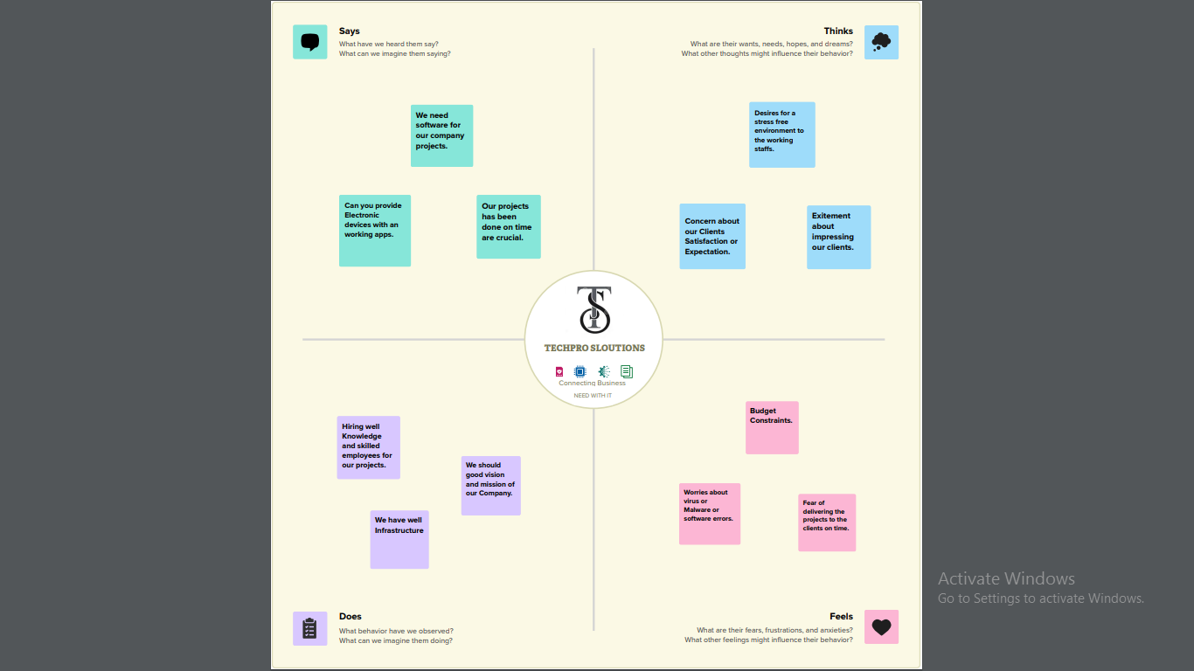

**2.2 IDEATION & BRAINSTORMING MAP:**

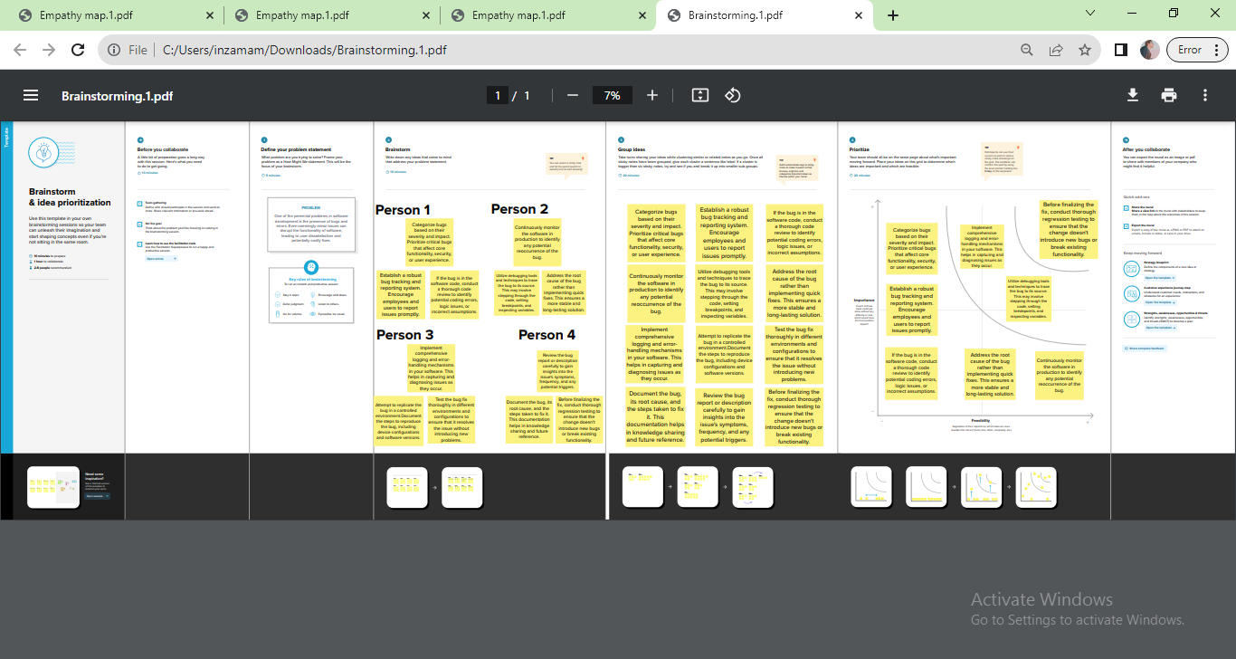

**3.RESULT**

The taking after functionalities made a difference us within the victory of the project:

**Profit & Loss**

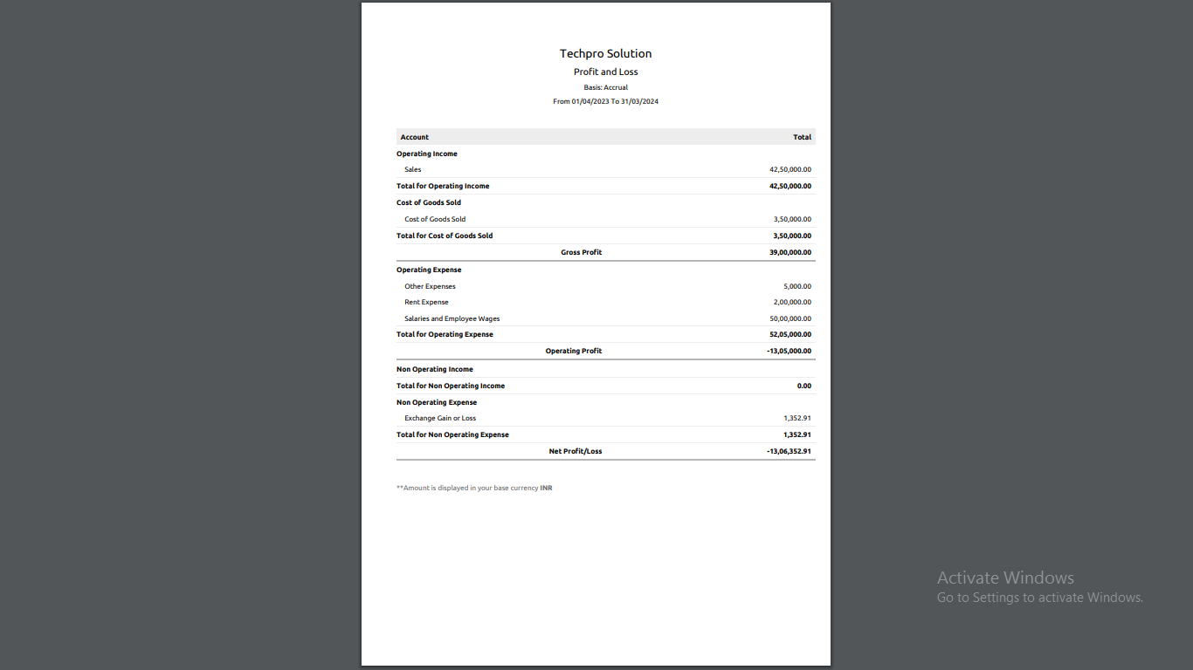

**Balance sheet**

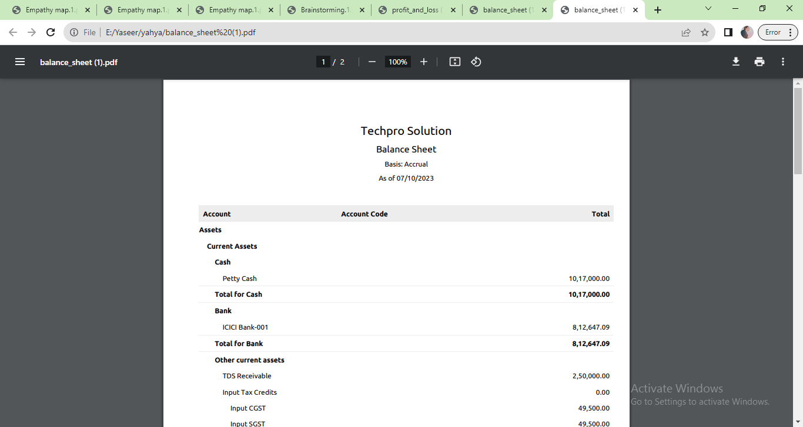

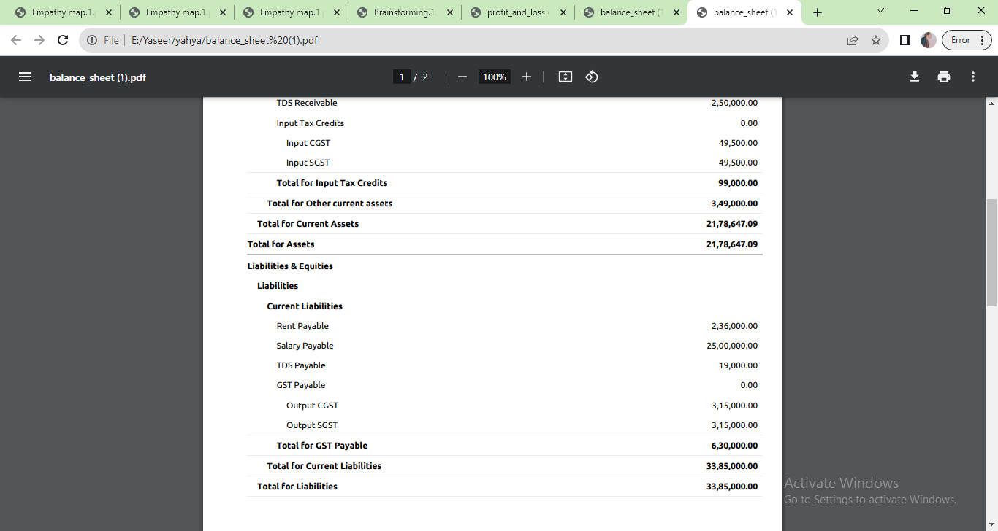

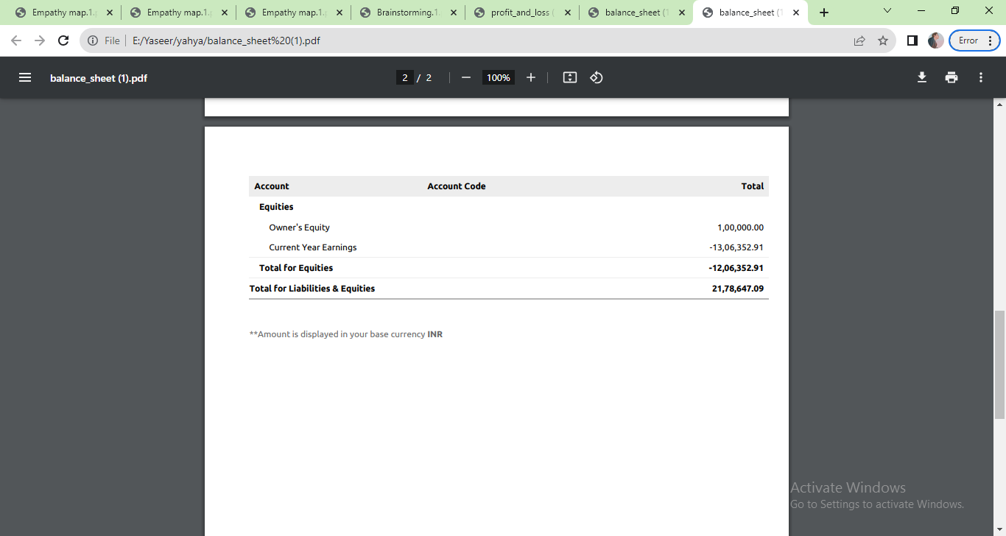

**4 ADVANTANGES & DISADVANTANGES**

The Information Technology (IT) sector plays a crucial role in modern society and the global economy. It offers numerous advantages, both for individuals and businesses. Some of the key advantages of the IT sector include:

1. **Innovation**: The IT sector is a hub of innovation. It constantly pushes the boundaries of technology, leading to new products, services, and solutions that improve our lives and drive progress in various industries.
2. **Efficiency**: IT systems and software automate and streamline various processes, making businesses more efficient and productive. This leads to cost savings and increased competitiveness.
3. **Global Connectivity**: IT enables people to connect with one another, regardless of geographical location. This connectivity is crucial for communication, collaboration, and the exchange of information on a global scale.
4. **Information Management**: IT systems allow for the efficient storage, retrieval, and analysis of vast amounts of data. This is invaluable for decision-making, research, and data-driven insights.
5. **Economic Growth**: The IT sector contributes significantly to economic growth by creating jobs, fostering entrepreneurship, and driving productivity improvements in various sectors.
6. **Flexibility**: IT systems can adapt to changing needs and requirements quickly. This is essential for businesses to remain competitive in an ever-evolving market.
7. **Cost Savings**: Cloud computing and virtualization have made IT infrastructure more affordable. It eliminates the need for large, costly physical data centers and allows businesses to pay for what they use.
8. **Improved Communication**: IT has revolutionized communication through email, messaging apps, video conferencing, and social media, making it easier to connect and share information with people across the globe.
9. **Automation**: IT enables the automation of repetitive tasks and processes, reducing the margin for error and freeing up human resources for more strategic and creative work.
10. **Security**: IT also plays a critical role in cybersecurity, helping to protect individuals, organizations, and governments from cyber threats and attacks.

**5. APPLICATIONS**

Information Technologies (IT) have a wide range of applications across various industries and aspects of modern life. Some of the key applications of IT include:

1. **Business Management**:

* Enterprise Resource Planning (ERP) systems for managing business processes.
* Customer Relationship Management (CRM) software for managing customer interactions.
* Project management tools for planning and monitoring projects.

1. **Communication**:

* Email, instant messaging, and video conferencing for real-time communication.
* Voice over Internet Protocol (VoIP) for making calls over the internet.
* Social media platforms for connecting and sharing information.

1. **Data Management**:

* Databases for storing, retrieving, and managing data.
* Big data analytics for extracting insights from large datasets.

1. **E-commerce**:

* Online shopping platforms for buying and selling goods and services.
* Payment gateways for secure online transactions.

1. **Education and E-Learning**:

* Learning management systems (LMS) for online education.
* Educational websites and apps for interactive learning
* Virtual classrooms and webinars for remote education.

1. **Healthcare**:

* Electronic Health Records (EHR) for managing patient information.
* Telemedicine and remote patient monitoring.
* Medical imaging and diagnostic software.

1. **Entertainment**:

* Video streaming platforms for movies and TV shows.
* Video games and virtual reality experiences.
* Music streaming services and digital content distribution.

1. **Education**: IT supports e-learning, virtual classrooms, and educational software for students and teachers.
2. **Financial Services**: IT is essential for online banking, algorithmic trading, risk management, and fraud detection in the financial sector.
3. **Energy Management**: IT helps monitor and optimize energy consumption in various sectors, including smart grids and energy-efficient systems.

**6 CONCLUSION**

Information technology has transformed the way we communicate, work, learn, and live, and its applications are diverse and wide-reaching. As we have explored throughout this project, IT is the backbone of modern businesses, industries, and societies, providing solutions that enhance productivity, efficiency, and innovation. The applications of IT are vast, ranging from communication and data management to healthcare, education, entertainment, and beyond. It supports critical functions in government, finance, transportation, and logistics, and it is pivotal in addressing global challenges like climate change through environmental monitoring and conservation. Furthermore, the rapid advancements in IT, such as artificial intelligence, machine learning, and the Internet of Things, continue to push the boundaries of what's possible, enabling smarter decision-making and automation across numerous domains. As we look to the future, the continued evolution of information technologies will undoubtedly bring even more transformative changes. It is essential for businesses, governments, and individuals to adapt and harness the power of IT to stay competitive and address the complex challenges of our time.

# FUTURE SCOPE

The future scope of information technologies (IT) is incredibly promising, as IT continues to evolve and reshape various aspects of our lives and industries. Here are some key areas where we can expect significant developments and opportunities in the field of IT:

1. **Artificial Intelligence and Machine Learning**: AI and machine learning are poised to play an even more significant role in the future. Applications include improved natural language processing, more advanced robotics, autonomous vehicles, and personalized AI-driven services.
2. **Quantum Computing**: Quantum computing has the potential to revolutionize computing power. It can solve complex problems that are currently impossible for classical computers, such as advanced cryptography, drug discovery, and climate modeling.
3. **Blockchain Technology**: Beyond cryptocurrencies, blockchain has applications in supply chain management, voting systems, and ensuring the integrity of digital records and transactions.
4. **5G and Beyond**: The deployment of 5G networks and beyond will lead to faster and more reliable connectivity, enabling the growth of the Internet of Things (IoT) and the development of innovative applications in areas like augmented reality, virtual reality, and telemedicine.
5. **Cybersecurity**: As technology advances, so do cyber threats. The demand for cybersecurity professionals and solutions will continue to grow as businesses and governments seek to protect their data and infrastructure.
6. **Healthcare IT**: Healthcare IT will expand, with the development of telemedicine, wearable health tech, and AI-driven diagnostics, improving patient care, and disease management.
7. **Smart Cities**: The concept of smart cities will gain momentum, with the integration of IT into urban planning, transportation, energy management, and public services for increased sustainability and quality of life.
8. **Sustainable Technologies**: IT can contribute to addressing environmental challenges through the development of sustainable technologies, such as smart grids, energy-efficient systems, and precision agriculture.
9. **Education Technology (EdTech)**: EdTech will continue to transform the way we learn, with more personalized and interactive learning experiences, online courses, and the use of AI for adaptive learning.
10. **Robotic Process Automation (RPA)**: RPA will automate repetitive tasks in various industries, reducing operational costs and improving efficiency.
11. **Data Analytics and Big Data**: The amount of data generated continues to grow. Advanced data analytics tools will help organizations derive valuable insights and make data-driven decisions.
12. **Cloud Computing**: The cloud will remain a key enabler for businesses, providing scalable and flexible IT resources. Serverless computing and edge computing are likely to become more prominent.